*Florida International University*

*School of Computing and Information Sciences*

CIS 4911 - Senior Capstone Project

Software Engineering Focus

Feature Document

User Story # 559

**Team Member:**

Garrett Lemieux

**Product Owner(s)**:

Francisco Ortega

**Mentor(s)**:

Francisco Ortega

**Instructor**: Masoud Sadjadi

**User Story – Reset Default Mode on Device Disconnect**

* As a User I would like to be able to disconnect any device or device breaks and have default mode updated so I can choose which devices to use in the program while its running.
* **Acceptance Criteria**:
  1. User must be able to disconnect any device or device breaks and default mode updated automatically.
  2. Correct functionality for each device must be set.

**Use Case**

User wants to choose which device to use while running application and have correct default mode set if device is disconnected.

* Details:
* Actor:
  + User

1. Pre-conditions:
   * TouchPoint app is running.
   * Desired devices connected.
2. Description:
   * Use case begins when User has decided to disconnected a specific device.
   * User can disconnected Multitouch.
   * User can disconnect Leap.
   * User can disconnect Real Sense.
   * User can disconnect EyeX.
   * Use case ends when default mode is updated.
3. Post-conditions:
   * TouchPoint app is running
   * Appropriate default modes is set based on the current devices connected.
4. Decision Support:
   * Frequency: Medium, User may want to change remove devices attached to program or device may malfunction requiring user to disconnect device.
   * Criticality: High, User must be able to control the devices running on the application at all times.
   * Risk: Low
5. Usability:
   * Only needs to be able to unplug desired device.
6. Reliability
   * High
7. Performance
   * Performance High
   * Failure Low
8. Supportability
   * Real Sense Device
   * MultiTouch
   * Leap Motion
   * EyeX
9. Modification History:
   * Owner: Garrett Lemieux
   * Initiation Date 4/7/2016
   * Date last Modified: 4/17/2016

**Use Case Diagram**

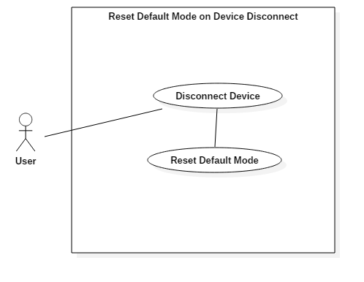

**Sequence Diagram**

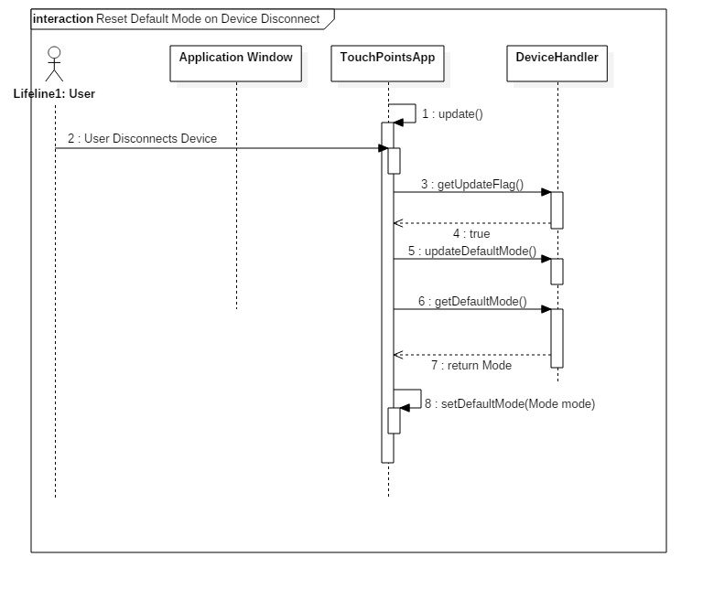

**Class Diagram**

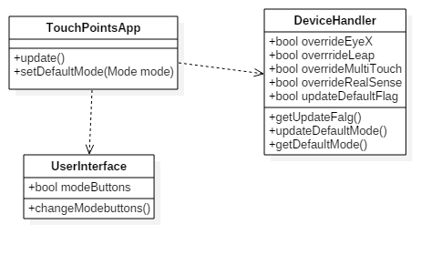

**Unit Test**

* Sunny Day Test:
  + Test Case  - Disconnect Multitouch Device
    - Test Purpose: To determine if the default mode is reset when multitouch device is removed while application is running.
    - Test Procedure: User starts program with multitouch, leap, and Real Sense Connected. He or she then disconnects multitouch device. Observes feedback and interacts with application.
    - Expected Results: After multitouch is disconnected buttons in left hand corner should disappear and UI menu should remain on canvas. User should be able to perform real sense facial gestures and draw with leap motion.
  + Test Case  - Disconnect Leap Device
    - Test Purpose: To determine if the default mode is reset when leap device is removed while application is running.
    - Test Procedure: User starts program with multitouch, leap, and Real Sense Connected. He or she then disconnects leap device. Observes feedback and interacts with application.
    - Expected Results: After leap is disconnected buttons in left hand corner should remain and UI menu should be on canvas if selected by using radial button. User should be able to perform real sense facial gestures and draw with multitouch.
  + Test Case  - Disconnect Real Sense Device
    - Test Purpose: To determine if the default mode is reset when real sense device is removed while application is running.
    - Test Procedure: User starts program with multitouch, leap, and Real Sense Connected. He or she then disconnects real sense device. Observes feedback and interacts with application.
    - Expected Results: After real sense is disconnected buttons in left hand corner should remain and UI menu should be on canvas if selected by using radial button. User should be able to perform leap gestures and draw with multitouch. User should not be able to draw with leap motion.
  + Test Case  - Disconnect EyeX Device
    - Test Purpose: To determine if the default mode is reset when eyeX device is removed while application is running.
    - Test Procedure: User starts program with multitouch, leap, and Real Sense, and eyeX connected. He or she then disconnects eyeX device. Observes feedback and interacts with application.
    - Expected Results: After eyeX is disconnected buttons in left hand corner should remain and UI menu should be on canvas if selected by using radial button. User should be able to perform real sense gestures and draw with multitouch. User should not be able to draw with leap motion.
* Rainy Day Test:
  + Test Case  - Multitouch quits working user removes device
    - Test Purpose: To determine if user removes a non-functioning multitouch device the default mode is reset.
    - Test Procedure: User starts program with multitouch, leap, and Real Sense Connected. He or she then disconnects non-functioning multitouch device. Observes feedback and interacts with application.
    - Expected Results: After multitouch is disconnected buttons in left hand corner should disappear and UI menu should remain on canvas. User should be able to perform real sense facial gestures and draw with leap motion.
  + Test Case  - Leap quits working user removes device
    - Test Purpose: To determine if user removes a non-functioning leap device the default mode is reset.
    - Test Procedure: User starts program with multitouch, leap, and Real Sense Connected. He or she then disconnects non-functioning leap device. Observes feedback and interacts with application.
    - Expected Results: After leap is disconnected buttons in left hand corner should remain and UI menu should be on canvas if selected by using radial button. User should be able to perform real sense facial gestures and draw with multitouch.
  + Test Case  - Real Sense quits working user removes device
    - Test Purpose: To determine if user removes a non-functioning real sense device the default mode is reset.
    - Test Procedure: User starts program with multitouch, leap, and Real Sense Connected. He or she then disconnects non-functioning real sense device. Observes feedback and interacts with application.
    - Expected Results: After real sense is disconnected buttons in left hand corner should remain and UI menu should be on canvas if selected by using radial button. User should be able to perform leap gestures and draw with multitouch. User should not be able to draw with leap motion.
  + Test Case  - EyeX quits working user removes device
    - Test Purpose: To determine if user removes a non-functioning eyeX device the default mode is reset.
    - Test Procedure: User starts program with multitouch, leap, and Real Sense Connected. He or she then disconnects non-functioning eyeX device. Observes feedback and interacts with application.
    - Expected Results: After eyeX is disconnected buttons in left hand corner should remain and UI menu should be on canvas if selected by using radial button. User should be able to perform real sense gestures and draw with multitouch. User should not be able to draw with leap motion.

**Integration Testing**

* Every combination of devices connected was tested. Each combination one device was removed and new default setting was observed. All functionality was test for remaining devices.
* After integrating reset default mode into the application all previous functionality was maintained and functioning correctly.

**User Guide**

* Devices Used: Acer Multitouch, Real Sense Device, Leap Motion, and EyeX

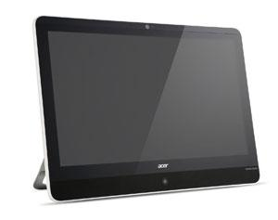

* Acer - Multitouch

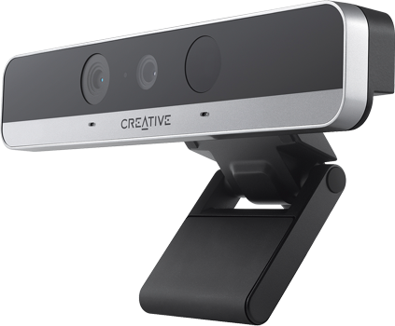

* RealSense Device

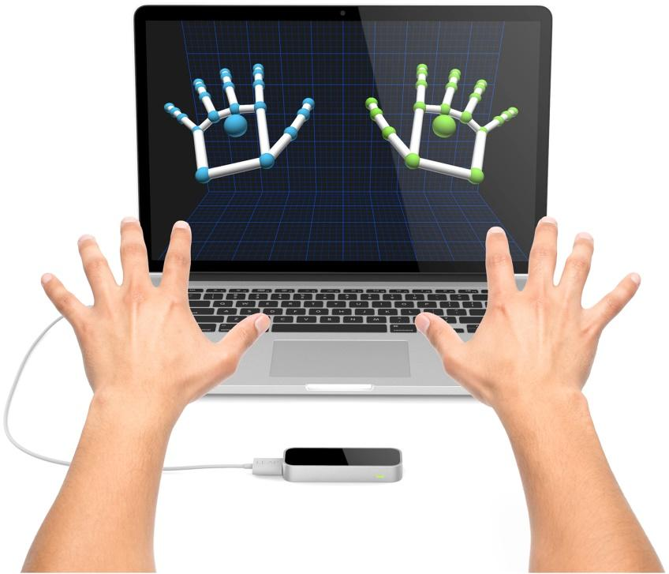

* Leap Motion

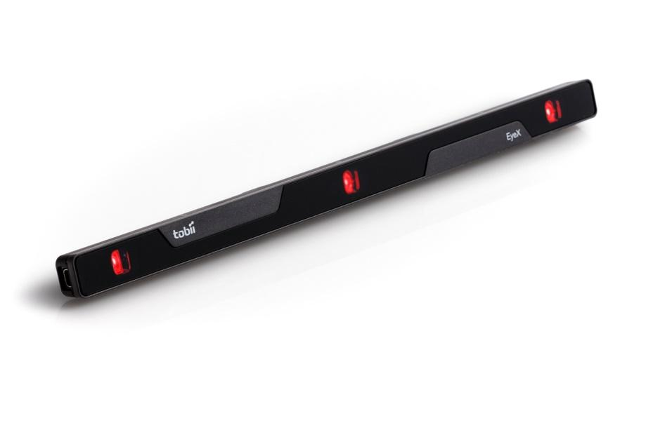

* EyeX
* User can have any combination of devices connected at beginning of program.
* At any point while running the application a user may remove a device and the default mode will automatically be reset. The user is not required to make any changes to the application
* If the user had already altered the current mode using the override buttons the default mode will not be updated since the user as chosen a custom device mode.

**Glossary**

* N/a